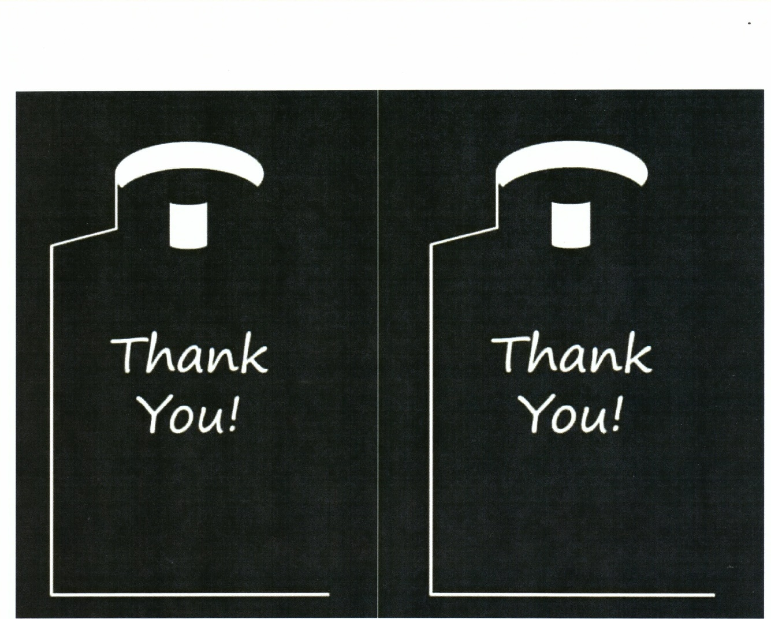
…for your vocation throughout the ….for your vocation throughout the
year but in particular during this year but in particular during this
commemoration of Our Savior’s birth. commemoration of Our Savior’s birth.
From: From:

Instructions: After your trim off these instructions, sign your name and your Scouting unit number, sponsor, and town after “From.” Trim the body of the card to fit into a long, business envelope. Mail the envelope in time to get to the seminarian or priest at least two weeks before Christmas.

